**Advanced Databases**

**MongoDB CA**

**Student Number:** C19513256

**Student Name:** Barnet Obeka

**Programme Code:** TU856

1. Setting up the cluster and replication

The cluster is composed of 3 interconnected nodes and all are part of the replication set









The message ok: 1 shows that the initiation and verification of the replication set were successful

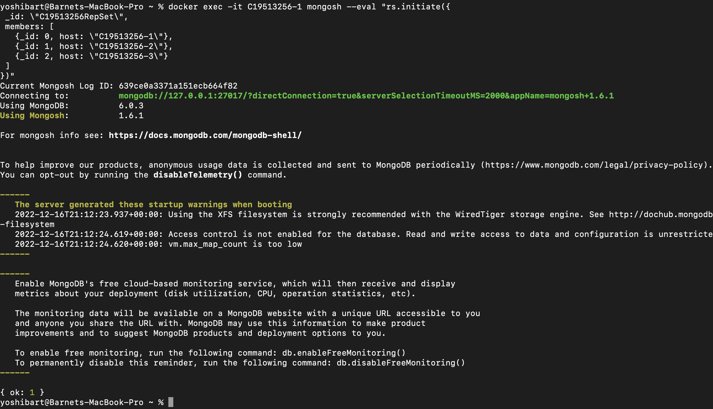

The replication set is up and running with 3 members. The number of votes required to win a vote e.g. a vote to become the primary node is 2 and the majority vote for writing is 2. In this case node, C19513256-1 won and it’s the primary node

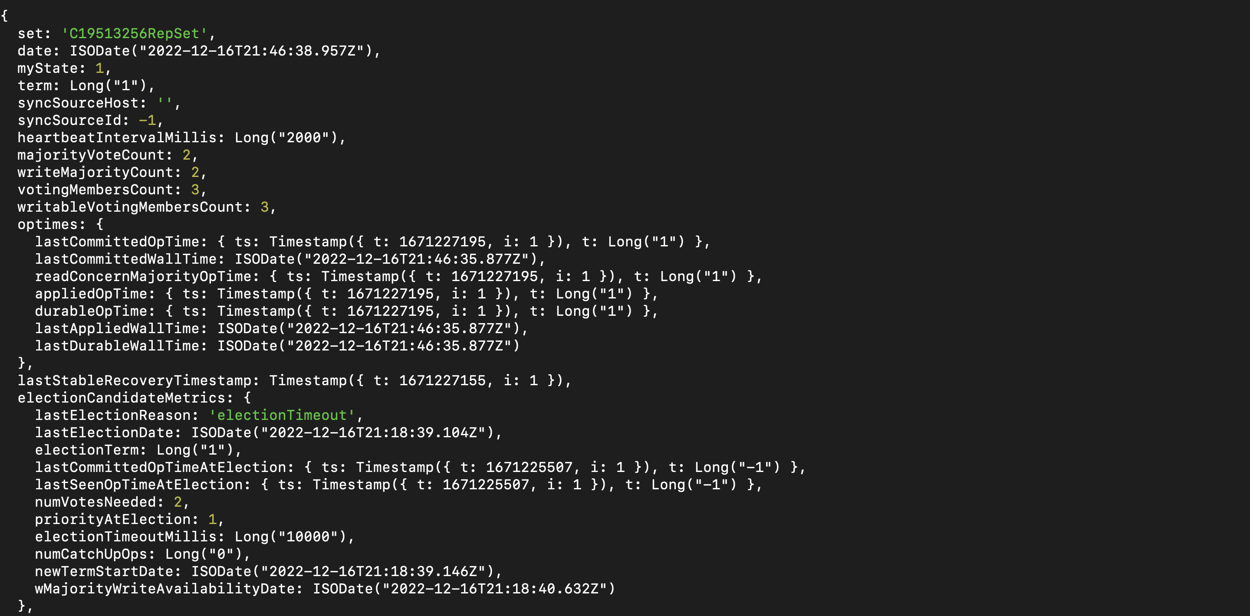

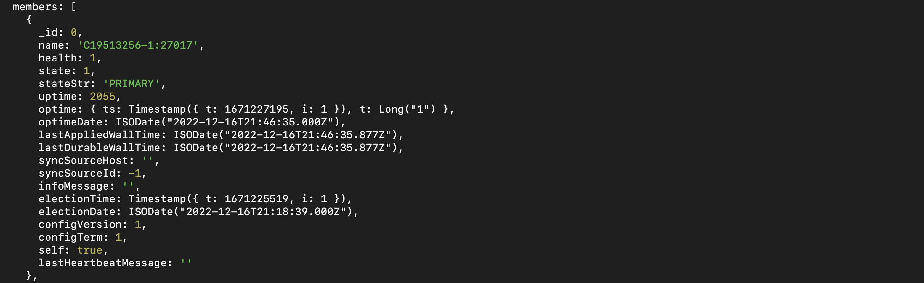

1. Porting the data to Mongo

The data inserted in the database using the insert statements generated during the connection between Cassandra and Mongo

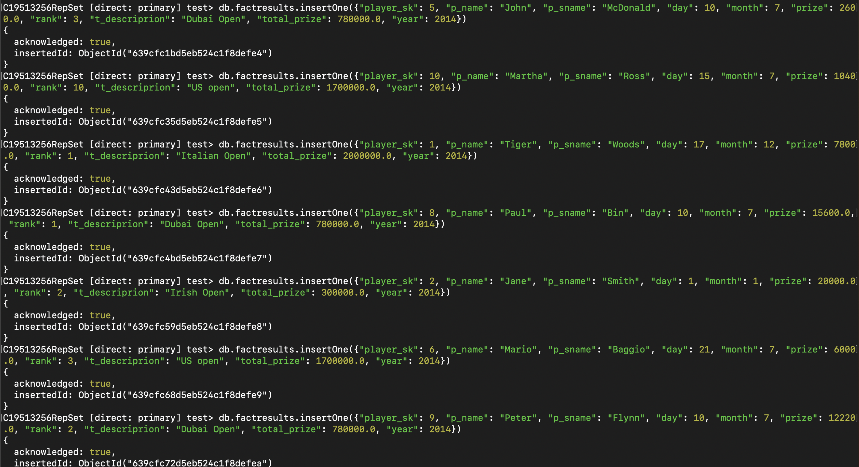

The mongo database includes 9 documents imported from Cassandra

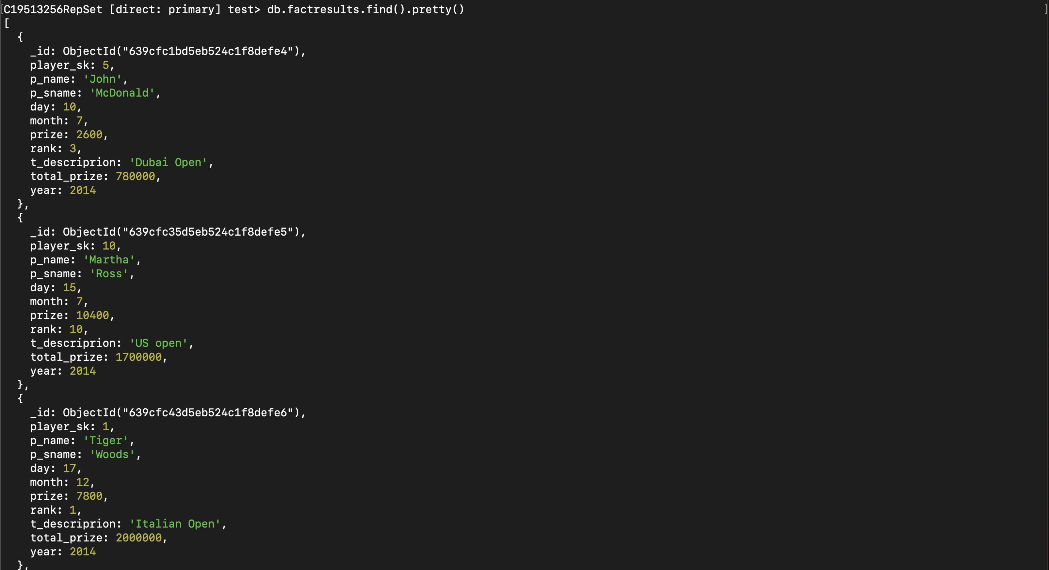

1. Working with the Golf collection in MongoDB:
   1. Basic query on golf data involving a text field.

The following query is searching for a document with the surname “Woods”

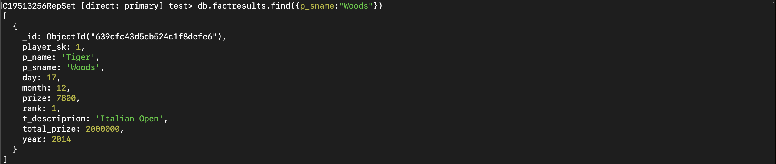

The winning plan is using the collection scan property which is similar to a sequential scan in Cassandra where each and every document is searched and results are returned. In this case, 7 documents are examined before a filter “Woods ” is found. And there were 0 rejected plans

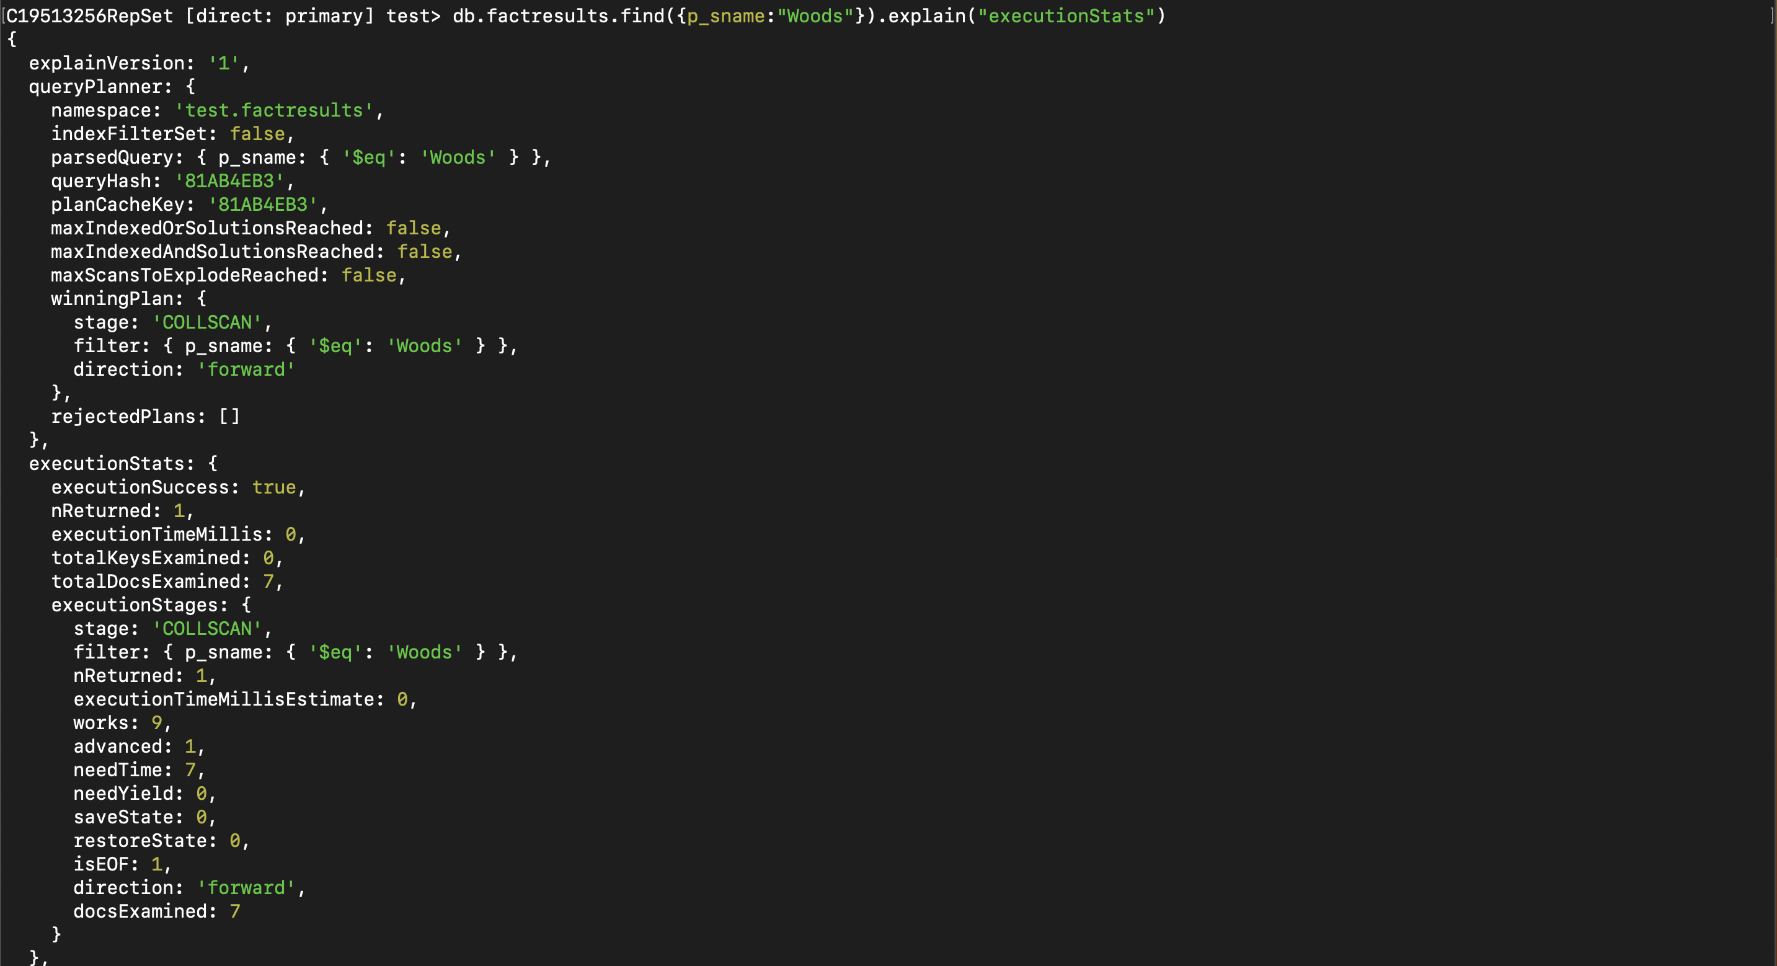

* 1. Adding a secondary index to golf data on a text field.

The index is created on the “p_sname” field



The index is verified using a similar query as in 3a. The index works because it uses “IXSCAN” for scanning documents. “FETCH” retrieves a single document and the single document is transferred to the Index scan stage where 1 key is explained with success. The estimated time of execution of FETCH and index scan is 1 millisecond

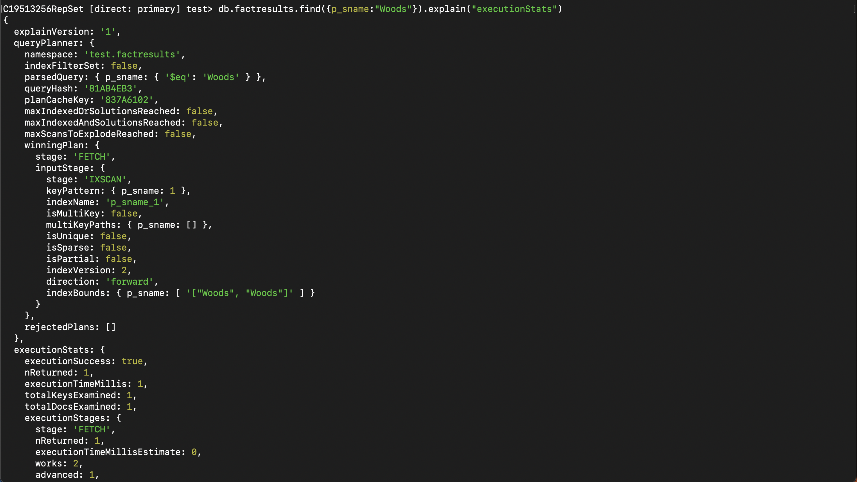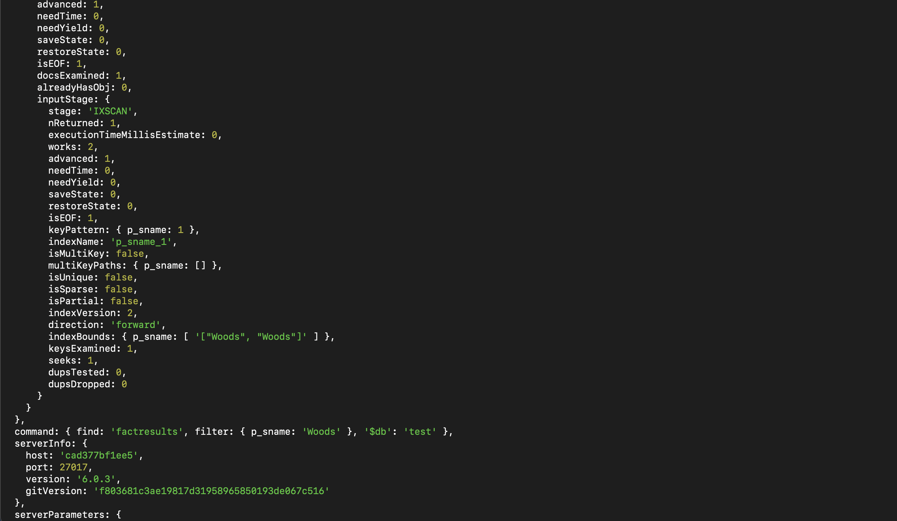

1. Working with aggregation in MongoDB:
   1. Create an aggregation pipeline

The following aggregation includes 2 stages. Starts by grouping, and then the total amount of money paid out for each golf tournament is calculated. Next, the output from the group stage is sorted by _id in descending order

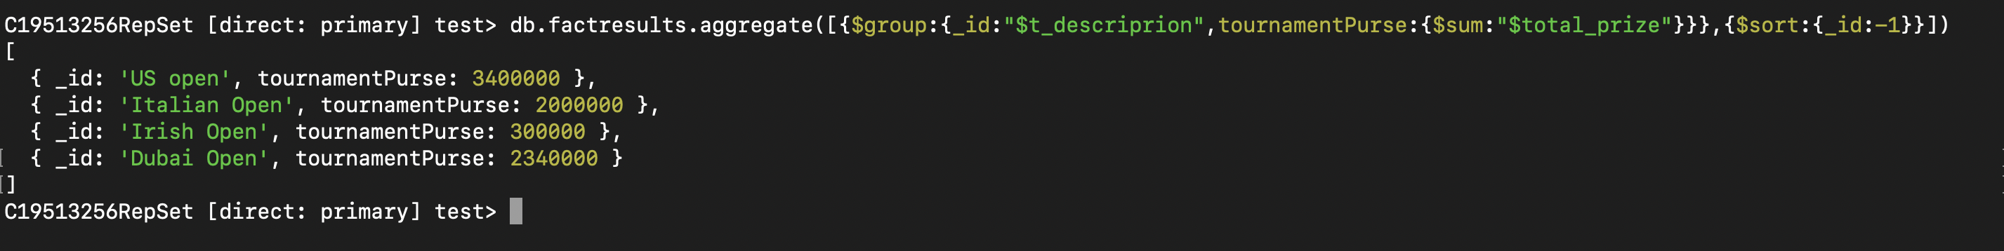

The aggregation execution winning plan starts in the GROUP stage and involves using the collection scan for all documents and filtering information using the tournament description. There are no rejected plans. There are 4 matches returned for different tournaments after the examination of 7 documents.

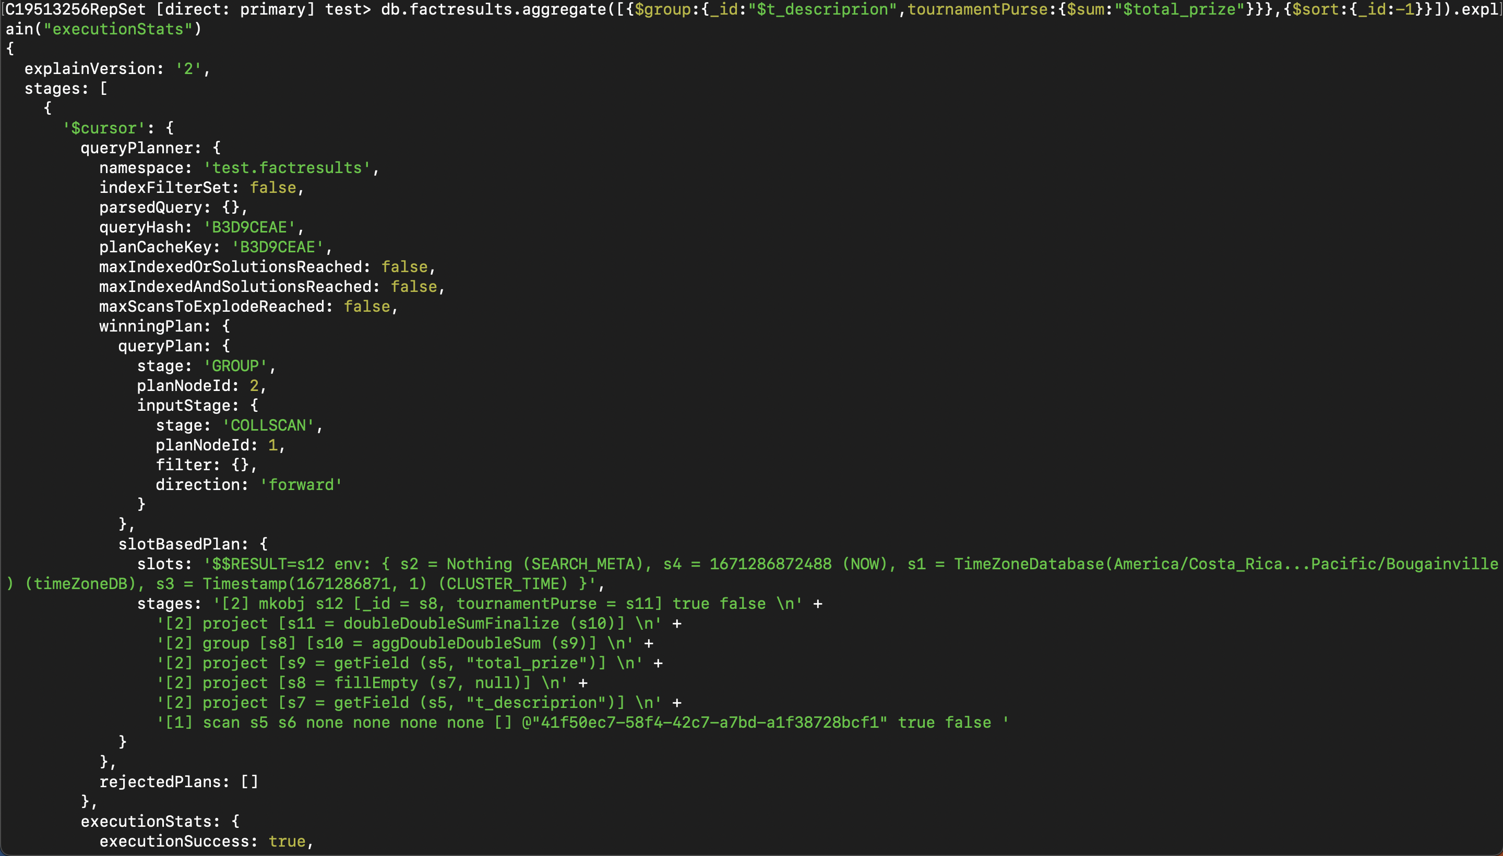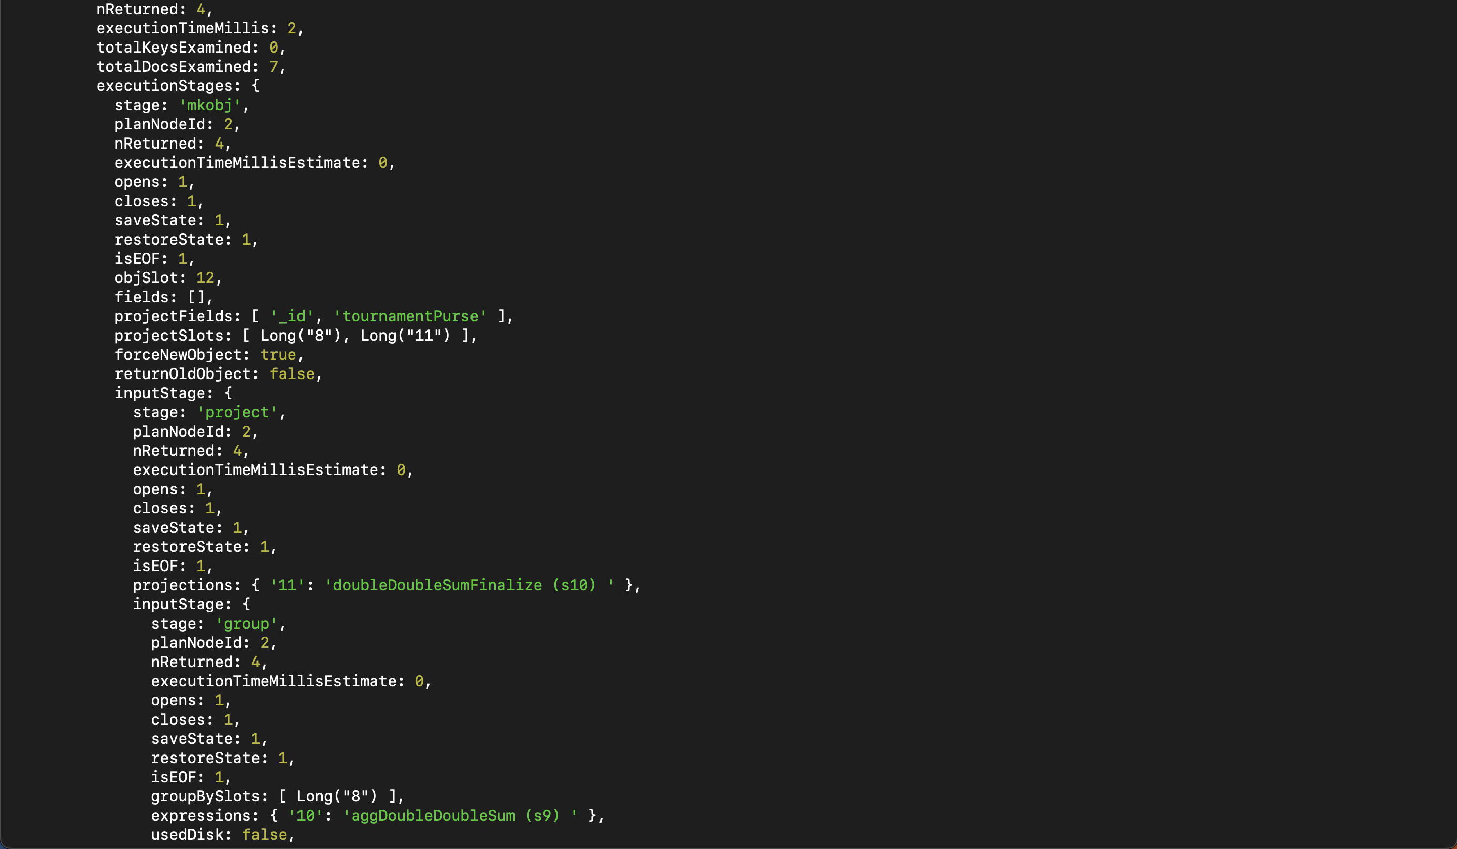

* 1. Add relevant indexes and reorder your stages.

The index is created on the tournament description fieldThe creation of an index is one form of stage optimization. The other in this case is switching the 2 stages in 4a. The first stage now is sorting the tournament description before piping the results to the group stage. This is more efficient because of no filtering to be done in the group stage.

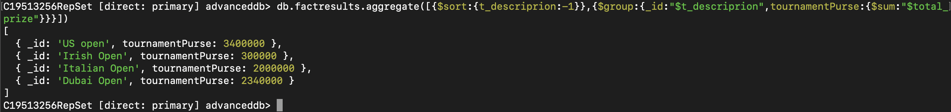

The winning execution plan involved using fetch to retrieve documents, and it's understandable because the aggregation involves grouping all documents and examining them and that’s where the 7 documents examined come from. The retrieved documents are passed to the index scan stage. The index on t_descriprion is used by IXSCAN for scanning keys and in this 7 keys were scanned.

There were no rejected plans and a number 4 entries are returned. The execution time is 2 milliseconds

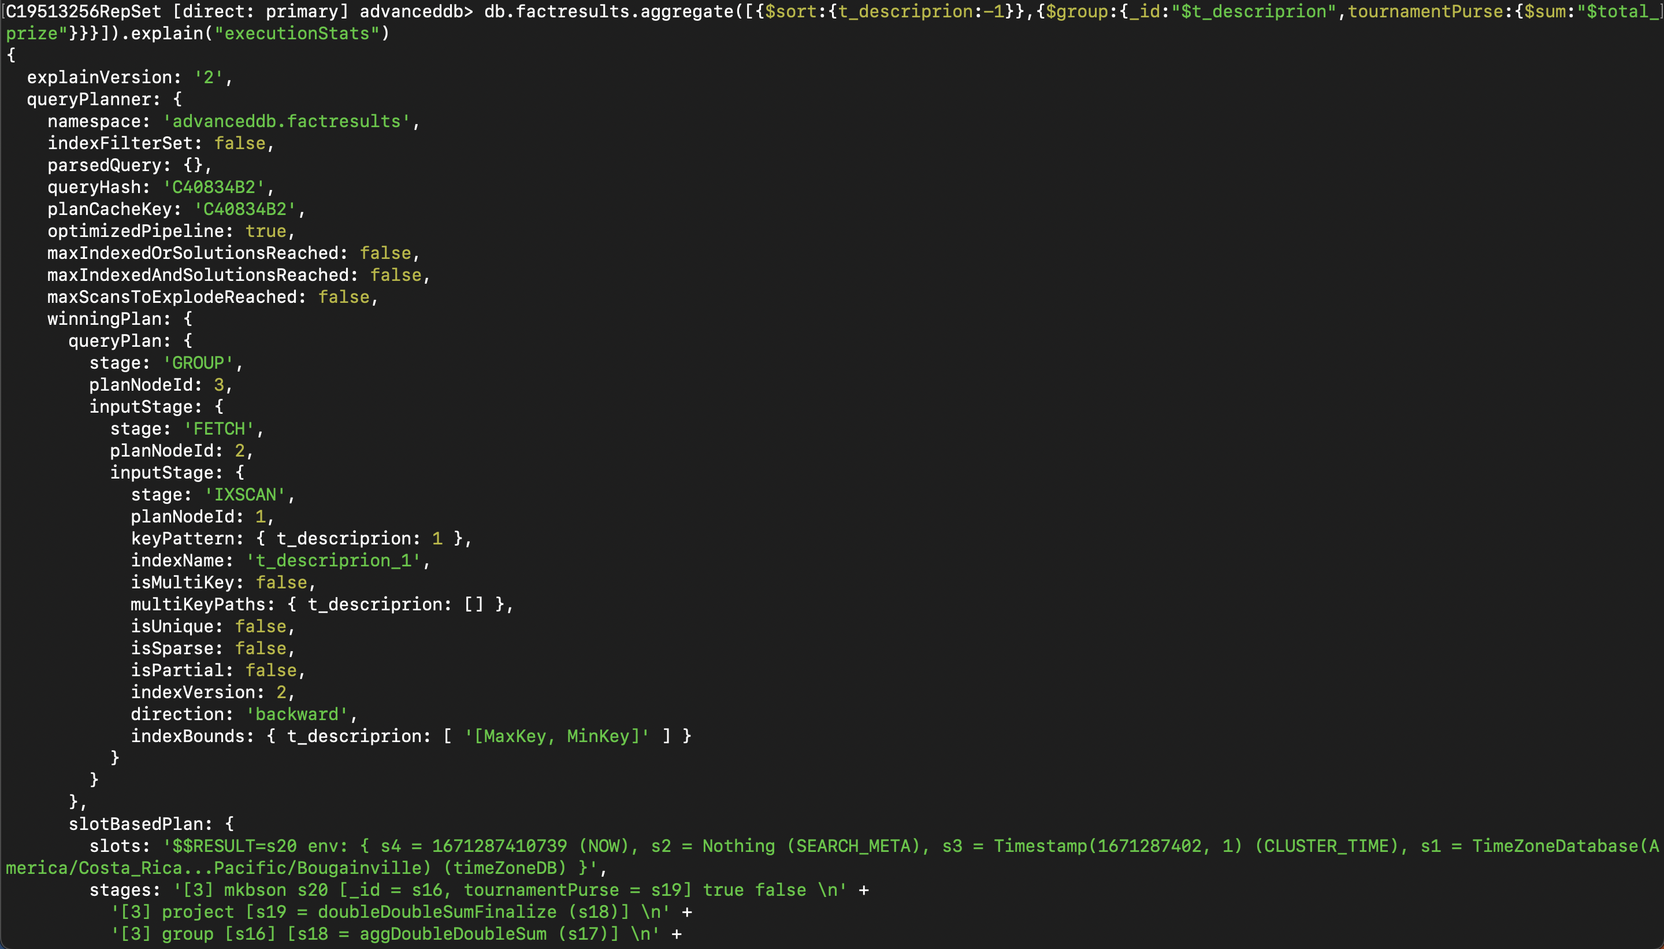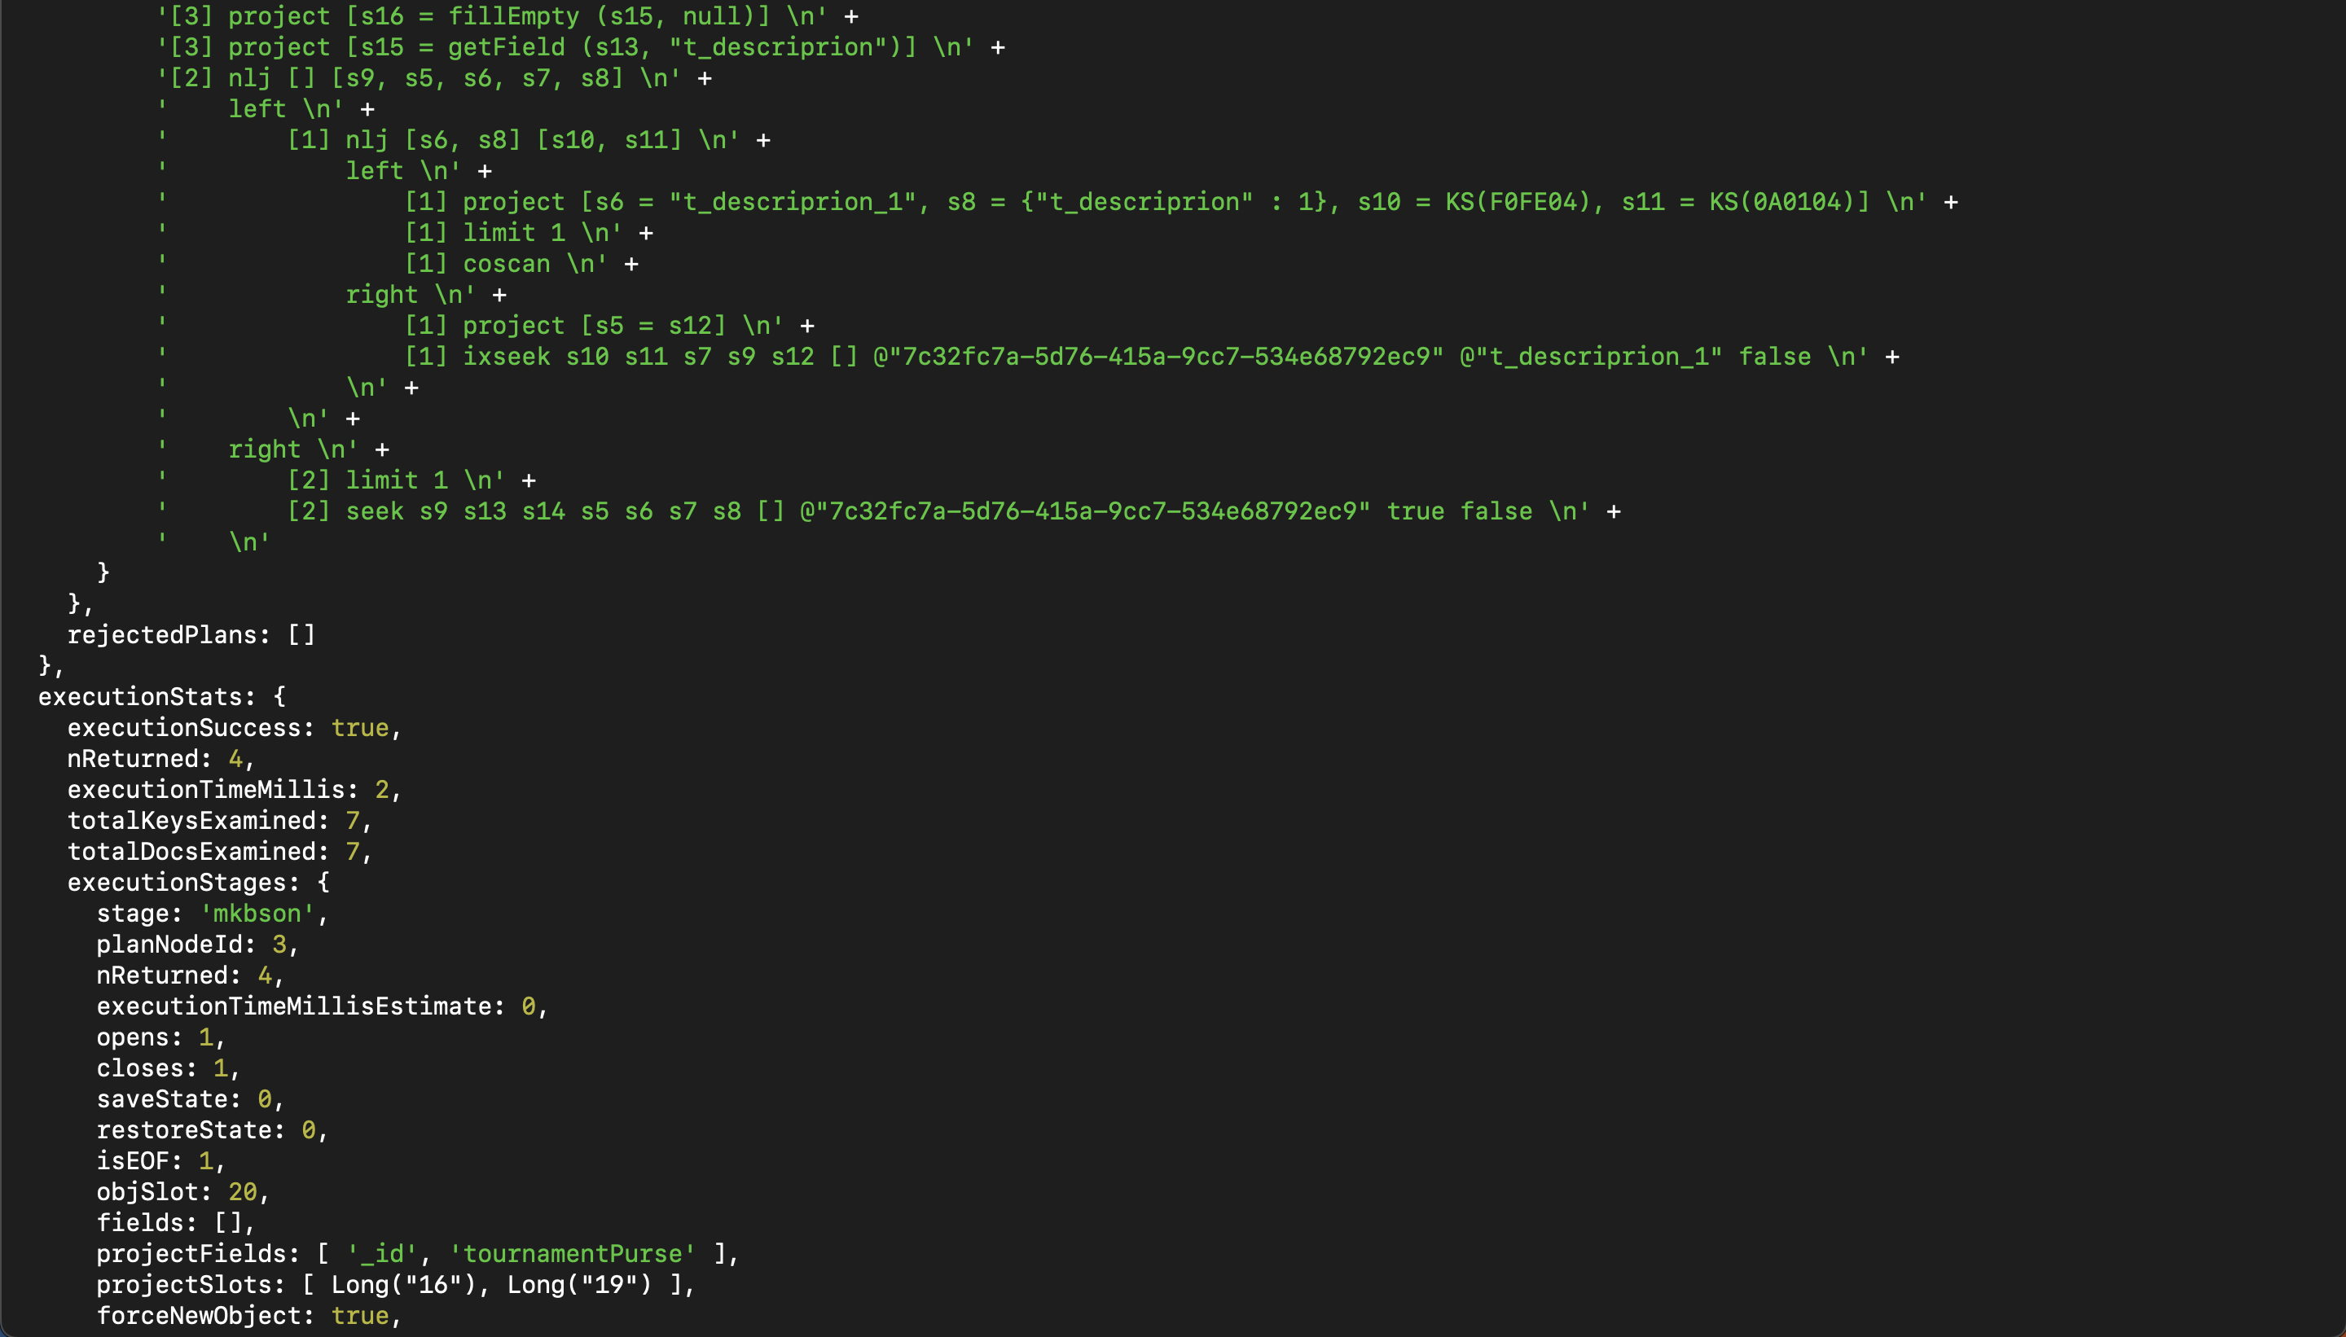

1. Replication working

In this case, when node C19513256-1 is paused it is reflected by the Replication set with the message “could not get a connection within a time limit “, leading to the conclusion that it's either unhealthy or unreachable. This prompt an election for the next primary node with the winner required to have a majority vote of 2 and in this case node C19513256-2 becomes the primary node

